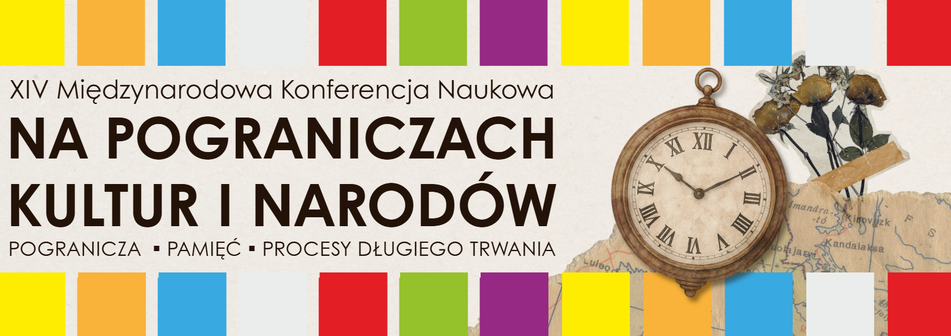Jan Grodek State University in Sanok
invites you to
XIV International Scientific Conference
"On the borders of cultures and nations.
"Borderlands – Memory – Long-term processes"
Sanok, September 17-19, 2026

Ladies and Gentlemen,
We cordially invite you to this year's 14th International Scientific Conference from the series "On the Borderlands of Cultures and Nations. Borderlands – Memory – Long-term processes", which will be held in a hybrid form on September 17-19, 2026 at the Jan Grodek State University in Sanok.
Once again, there is an opportunity to present the current state of the latest research and a creative perspective on the issue of borderlands understood not only in spatial and ethnic categories, but also as a meeting place for different communities, diversified not only socially, but also religiously and culturally, with their mutual influence on each other.
We invite researchers of various specializations from research centers in Poland and abroad to a meeting and scientific dialogue, assuming a wide range of presentation of problems in the historical and contemporary dimension, in many aspects - sociological, economic, cultural, religious and educational.
The main theme of the conference will be "Transformation, Adaptation, Continuation". We invite you to submit papers on the topics presented below:
- borderlands – long-terms processes;
- experiences of otherness on the borderlands;
- the Polish borderland facing the challenges of the modern world;
- changes in secular and religious, annual and family customs; " own" and "other" customs - duration and change;
- cultivating own (national or regional) cultural tradition and external influences;
- denominations (religions), churches and their relations on the borderlands; church structures on the borderlands;
- sacred art on the borderlands: preservation of own artistic (stylistic) tradition and the influence of other ("foreign") artistic patterns;
- "our own" and "foreign" artistic environment; artists from the borderland and contemporary forms of popularizing art on the borderlands; artistic movement of national minorities, forms of cultivating their own culture; borderland in cultural policy (state and local);
- artistic heritage on the borderlands (troublesome, fragmented, pluralistic, common or categorized as different and foreign, heritage as a product); valorization – conservation and museum activities;
- armed conflicts on the borders;
- internal security on the borders;
- issues of economic policy in border regions – the economic dimension of cross-border relations; opportunities and barriers to entrepreneurship development in border areas; disproportions in the state of (technical) infrastructure – borderlands and other areas; development strategies for regions and subregions;
- the state as "my own" (mine) or a distance?; other scopes of political awareness;
- national minorities on the borderlands: their sense of their own identity and its relation to the identity of another national group;
- ways of defining the identity of a group, community, individual in relation to the "other" and to "our own" - conflicts or tolerance;
- multicultural society: social and cultural relations on the borderlands, at the interface of ethnicities, religions, cultures, nations, diffusion of cultures on the borderlands;
- economic (cross-border) migrations;
- similarities and differences of Polish borderlands;
- educational dimension of migration;
- issues of education of national minorities in the borderlands;
- value and protection of the natural and cultural landscape in the process of economic modernization of the borderlands; natural and environmental resources and their protection or degradation under the slogan of development and economic and technical progress.

We are also open to proposals that go beyond the given framework and relate to issues of borderlands, economy, sociology and culture.

Conference registration form and the latest information are available at up-sanok.edu.pl/pogranicza .

CONFERENCE SCIENTIFIC COMMITTEE

- Prof. Violetta Dutchak, Vasyl Stefanyk Precarpathian National University in Ivano -Frankivsk
- Prof. Dr. Hab. Jarosław Kita, University of Lodz
- Prof. Dr. Hab. Zbigniew Libera, Jagiellonian University
- Prof. Dr. Hab. Sergey Trojan, Diplomatic Academy of Ukraine
in Kyiv
- Prof. Bohdan Yuskiv, Rivne State Humanities University
- dr hab. Tomasz Chomiszczak , prof. UKEN - University of the National Education Commission in Krakow
- dr hab. Mateusz Kaczmarski, prof. UP - Jan Grodek State University in Sanok
- dr hab. Piotr Frączek, prof. UP – Jan Grodek State University in Sanok
- Dr. Liubov Gunder , University of Prešov
- Dr. Hab. Robert Lipelt , prof. UP - Jan Grodek State University in Sanok - chairman
- dr hab. Katarzyna Smyk, prof. UMCS - Maria Curie-Skłodowska University in Lublin

ORGANIZING COMMITTEE
- Dr. Eng. Monika Krawczyk – Chairwoman
- Dr. Jolanta Karolczuk
- M.Sc. Eng. Ewa Stączek – conference secretary

CONFERENCE PARTNERS

- Polish Studies Scientific and Information Center named after Igor Meniok of the Ivan Franko State Pedagogical University in Drohobych
- Museum of Folk Architecture in Sanok
- Historical Museum in Sanok
- Municipal Public Library named after Grzegorz of Sanok in Sanok
- Institute of Cultural Studies, Maria Curie-Skłodowska University in Lublin
- Polish Historical Society, Sanok Branch

Availability:
People with disabilities can report special needs to Marcin Owsiak, niepelnosprawni@up-sanok.edu.pl ,
tel. : (+48) 134655975

Fees:
- 200 PLN – conference fee
- free of charge – invited lecturers, guests and members of the Scientific and Organizing Committee
- free of charge – online participation
The conference fee of PLN 200 should be transferred by 31 August 2026, to the account
No.: PKO BP 67 1020 2980 0000 2302 0020 7837 with the note: "Conference POGRANICZE 2026, Name and Surname of the participant"

Dates:
- Please send your application for participation in the conference on the attached application form to the following address: pogranicza@up-sanok.edu.pl by 31 July 2026 or by traditional mail to the following address: Jan Grodek State University
in Sanok, ul. Mickiewicza 21, 38-500 Sanok, with the note: "Pogranicza".
- The Scientific Committee will inform about the acceptance of the paper by August 15, 2026 .

The joint meetings and discussions will result in the publication of a monograph, "NA POGRANICZACH" (ON THE BORDERLANDS).
Only papers that receive positive reviews will be accepted for publication.
The conference monograph will be published by a reputable scientific publisher.
The conference publication fee of PLN 200 must be transferred to the following account by September 10, 2026.
Account number: PKO BP 67 1020 2980 0000 2302 0020 7837
with the note: Conference POGRANICZE KiN 2026, Participant's name and surname
SWIFT CODE: BPKOPLPW

We cordially invite you to participate in the Conference

