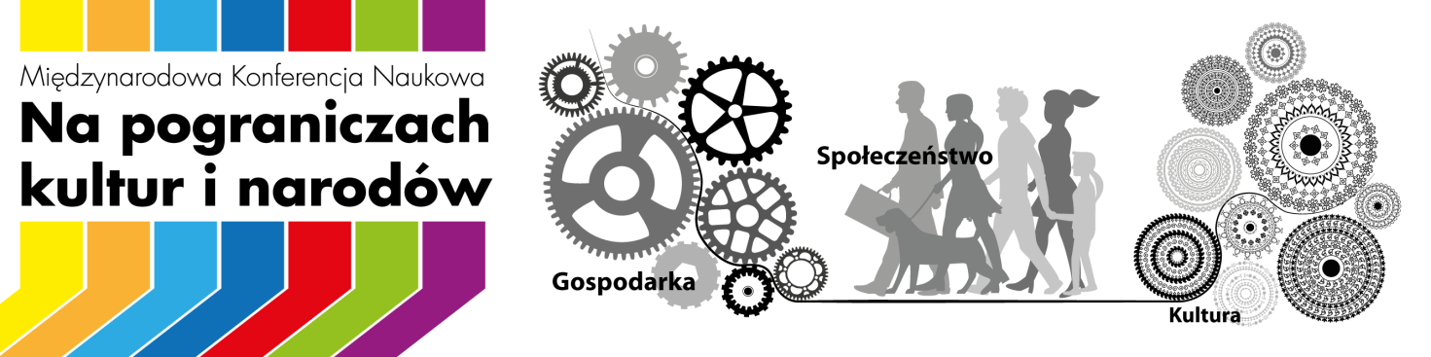

9th International Scientific Conference
At the borderline of cultures and nations.
Locals – Strangers – Others
Sanok, 16th-18th September, 2021

THE ORGANIZERS



SCIENTIFIC PATRONAGE
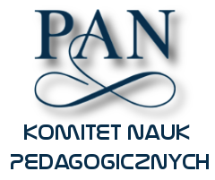
The Committee of Pedagogical Sciences
the Polish Academy of Sciences

'The frontier’ is a concept with a broad field of meaning, expressing both barriers and areas of interpenetration of different cultures, religions, nations and ethnic groups, economic and legal systems. As a place, ‘the frontier’ is a particularly suitable context for the exchange of ideas and experiences, and if it takes place in an academic institution, it can become the nucleus of international scientific dialogue and local social impact. Jan Grodek State University in Sanok will once again become such a place during the 9th International Scientific Conference ‘At the borderline of cultures and nations. Locals-Strangers-Others’.
The organizers invite researchers, educators and social ambassadors of multicultural borderland from Poland and abroad, interested in the issues of history, sociology, economy, pedagogy, culture and art of areas on the border of states and nationalities.

THEMATIC SCOPE OF THE CONFERENCE:

Historical and cultural issues of the borderland:
• sense of national identity and national minorities in the borderlands,
• changes in secular and religious, annual and family customs,
• denominations, churches, religions and their relations on borderlands,
• structures of the church in the borderlands,
• sacred art in the borderlands: restoration - conservation and museum activities,
• artist (of) borderline and contemporary art forms of dissemination of the border,
• diffusion of cultures in the borderlands,
• heritage in the borderlands (troublesome, fragmented, pluralistic, heritage as a product),
• history and present day politics and economy of border regions
• borderland in cultural policy and development strategies of regions and sub-regions.

Socio-economic contexts of the functioning of the borderland nations:
• ways of determining the identity of the group, the community, the individual in relation to the "other" and to "his" - conflicts and tolerance,
• multicultural society,
• demographic changes in the borderland areas,
• economic and social dimension of the cross-border relationships - perspectives and dilemmas,
• economic migrations,
• disability - experience of discrimination,
• entrepreneurship and creative industries in the borderlands - opportunities and barriers to development,
• social and cultural relations on the borderlands and at the meeting point of ethnoses, religions, cultures and nations,
• health in the borderlands
• internal security in the borderlands.

Education and science as factors in the development of the borderland community:
• educational dimension of the synergy of borderland societies,
• (higher) school and migration phenomena - institutional changes,
• transnational childhood - experiences of children of migrants and migrant children,
• educational migrations - motivations, experiences, professional choices of foreign students,
• disability and migration - experiencing discrimination in education from an intersectional perspective.

SCIENTIFIC COMMITTEE:
- dr hab. Robert Lipelt, prof. UP - Jan Grodek State University in Sanok (Poland) - Chairman of Scientific Committee
- dr hab. Michał Kwiatkowski, prof. APS - The Maria Grzegorzewska University (Poland) - Vice Chairman of Scientific Committee
- prof. dr hab. Jarosław Kita, University of Lodz (Poland)
- prof. dr hab. Stefan M. Kwiatkowski, Vice Chairman of CPS PAS, The Maria Grzegorzewska University (Poland)
- prof. dr hab. Zbigniew Libera, Jagiellonian University of Cracow (Poland)
- prof. dr hab. Mirosław J. Szymański, Vice Chairman of CPS PAS, The Maria Grzegorzewska University (Poland)
- prof. Siergiej Trojan, Udovenko Diplomatic Academy of Ukraine Ministry of Foreign Affairs (Ukraine)
- prof. Bohdan Yuskiv, Rivne State University of Humanitarian (Ukraine)
- dr hab. Tomasz Chomiszczak, prof. UP - Pedagogical University of Cracow (Poland)
- dr hab. Agnieszka Olechowska, prof. APS - The Maria Grzegorzewska University (Poland)
- dr hab. Mirosława Pindór, prof. UŚ - University of Silesia in Katowice (Poland)
- dr hab. Katarzyna Smyk, prof. UMCS - The Maria Curie - Skłodowska University in Lublin (Poland)
- dr hab. Danuta Uryga, prof. APS - The Maria Grzegorzewska University (Poland)
- dr hab. Dariusz Wojakowski, prof. AGH University of Science and Technology (Poland)
- dr Justyna Bluszcz, The Maria Grzegorzewska University (Poland)
- dr Piotr Frączek, Jan Grodek State University in Sanok (Poland)
- dr Jolanta Karolczuk, Jan Grodek State University in Sanok (Poland)
- dr Katarzyna Serwatko, Jan Grodek State University in Sanok (Poland)
- dr Krzysztof Symela, The Łukasiewicz Research Network – The Institute for Sustainable Technologies in Radom (Poland)
CONFERENCE PARTNERS:

- Polish Studies Center of the Pedagogical University of Ivan Franko in Drohobycz
- Museum of Folk Architecture in Sanok
- Historical Museum in Sanok
- Ethnocenter of the Krosno Region

SUBMITTING ARTICLES FOR PUBLICATION

This year, we offer conference participants the opportunity to publish articles in one of several publications (list below). The decision to classify a text for a monograph or journal is made by the Scientific Committee of the conference. The author(s) of the article will be required to edit the text according to the requirements specified for the monograph / journal.
1. Articles on historical, cultural and socio-economic issues may be published in a monograph edited by an academic.

NA POGRANICZACH / ON THE BORDERLANDS  (scientific edited monograph)  language: Polish  admission requirements: positive editorial reviews  more: https://animoto.com/play/HuxfCjrLd0w2Pic8iQ5obg  email: pogranicza@up-sanok.edu.pl | 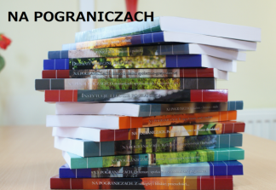
2. Autors of articles related to the issues of pedagogy and andragogy and an interdisciplinary nature (historical, social, economic), will be offered to publish the text in one of the following scientific journals:

Journal of Continuing Education  (Edukacja Ustawiczna Dorosłych)  language: Polish, English  admission requirements: positive 2 scientific reviews (external)  more: www.edukacjaustawicznadoroslych.eu | 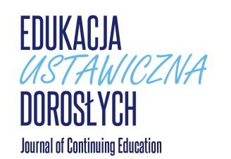
Man - Disability - Society  (Człowiek - Niepełnosprawność - Społeczeństwo)  language: Polish, English  admission requirements: positive 2 scientific reviews (external)  more: https://cnsonline.pl | 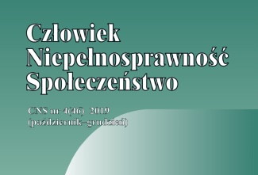
Special School  (Szkoła Specjalna)  language: Polish, English  admission requirements: positive 2 scientific reviews (external)  more: https://e-szkolaspecjalna.pl | 
Issues in Childhood Care and Education  (Problemy Opiekuńczo-Wychowawcze)  language: Polish, English  admission requirements: positive 2 scientific reviews (external)  more: https://problemyopiekunczo-wychowaw.pl | 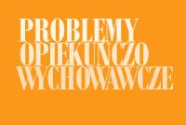
Social Work  (Praca Socjalna)  language: Polish, English  admission requirements: positive 2 scientific reviews (external)  more: https:// e-pracasocjalna.pl | 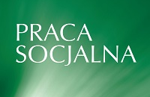
INTERNATIONAL JOURNAL OF PEDAGOGY, INNOVATION AND NEW TECHNOLOGIES (IJPINT)  language: English  admission requirements: positive 2 scientific reviews (external)  more: https://ijpint.com | 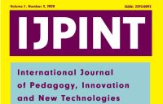

INFORMATION FOR PARTICIPANTS

Deadline:
- The application form should be sended to: pogranicza@up-sanok.edu.pl by 31th July 2021 or by mail to: Uczelnia Państwowa im. Jana Grodka w Sanoku, ul. Mickiewicza 21, 38-500 Sanok, Poland, with a note: „Pogranicza”.
- The Scientific Committee will announce the acceptance of the paper by 10th August 2021
- The conference fee must be paid by 10th September 2021.

Cost of participation in the conference:
- 510 PLN – Accommodation, conference materials, catering, banquets, museum tours, peer reviewed publications
- 390 PLN – As above, without accommodation
- 450 PLN– For guests from Ukraine, Belarus and Moldova
- 80 PLN– banquets
- no fees – for people representing the organizers and partners of the Scientific Committee of the conference.

Account numer: PKO BP 67 1020 2980 0000 2302 0020 7837
title: POGRANICZE KiN 2021, Participant(s) First and Last Name
KOD SWIFT: BPKOPLPW

Application form and the latest news at:
www.up-sanok.edu.pl/pogranicza

All questions send to: pogranicza@up-sanok.edu.pl

ORGANIZING COMMITTEE:
dr Jolanta Karolczuk – Chairman, Jan Grodek State University in Sanok
dr Katarzyna Serwatko - Vice Chairman, Jan Grodek State University in Sanok
dr Jarosław Korczak – The Maria Grzegorzewska University

SECRETARY OF ORGANIZING COMMITTEE:
mgr Anna Futyma

