


Blended Intensive Programme

Alanya Alaaddin Keykubat University, Antalya/Alanya, Türkiye

Organise a course for undergraduate students

ENGINEERING A CLIMATE-RESILIENT, WATER-SMART AND POLLUTION-FREE AVIATION FUTURE WITH ARTIFICIAL INTELLIGENCE

VIRTUAL PART
OPEN SCHEDULE COURSE
11st-15th May 2026

FACE TO FACE 3 ECTS
18th-22nd May 2026
Venue: Alanya Alaaddin Keykubat University, Antalya/Alanya, Türkiye
2024-1-TR01-KA131-HED-000195913
Abstract
Engineering a Climate-Resilient, Water-Smart and Pollution-Free Aviation Future with Artificial Intelligence is an interdisciplinary Erasmus+ Blended Intensive Programme designed to address the urgent sustainability transformation required in the aviation sector under the Net-Zero 2050 agenda and the European Green Deal framework. The programme responds to the structural challenges posed by climate change, water scarcity, environmental pollution, and digital transformation by integrating engineering, artificial intelligence, environmental sciences, governance, and infrastructure planning. It moves beyond conventional aviation education by embedding climate science, AI-driven emission modelling, water resilience strategies, and environmental risk governance into a unified academic platform.
Through a blended learning structure combining virtual theoretical foundations with applied physical workshops, participants engage in carbon accounting simulations, AI optimisation labs, pollution mapping exercises, and interdisciplinary project development. The course fosters systems thinking and equips students with the analytical, technical, and policy-oriented competences required to design climate-resilient and environmentally responsible aviation systems. By operationalising Sustainable Development Goals (SDGs 4, 5, 6, 7, 9, 11, 12, 13, and 15) into measurable engineering and governance applications, the programme transforms sustainability from a conceptual discourse into a practical and innovation-driven educational mode.

Key topics include:

- 1. Climate Science and Governance
- Climate science for decision-makers
- Global climate governance and international agreements
- Aviation environmental responsibility frameworks
2. Artificial Intelligence and Digital Transformation
- AI in emission modelling
- Machine learning for operational optimisation
- Predictive analytics and optimisation models
- Digital twin technologies for sustainability monitoring
3. Environmental Management and Pollution Control
- Carbon footprint analysis and lifecycle assessment
- Environmental Management Systems
- Noise and air pollution mapping methodologies
- Environmental risk assessment models
4. Water Sustainability and Circular Systems
- Airport water footprint assessment
- Smart water management systems
- Greywater recycling and circular resource management
5. Clean Energy and Future Technologies
- Sustainable Aviation Fuels (SAF)
- Hydrogen and electric propulsion systems
- Energy-efficient infrastructure design
6. Sustainable Infrastructure and Policy Integration
- Climate-resilient infrastructure planning
- SDG-integrated modelling approaches Water-saving strategies at both individual and societal levels
- The role of green infrastructure in water management, such as rainwater harvesting and green roofs

Methods for the course:
The course adopts a blended, interdisciplinary and practice-oriented teaching methodology that integrates theoretical knowledge with applied problem-solving. The virtual component provides the conceptual foundation through interactive lectures, guided discussions, climate data interpretation exercises, and AI-based emission modelling demonstrations delivered via digital learning platforms. During this phase, students engage in collaborative online workshops, policy analysis sessions, and structured mentoring to define sustainability challenges and develop preliminary project concepts. The physical mobility phase emphasises experiential learning through carbon accounting simulations, artificial intelligence optimisation laboratories, environmental mapping exercises (including noise and air quality assessment), and water management case studies. Participants work in multinational, interdisciplinary teams using data-driven tools and modelling software to design climate-resilient and environmentally responsible infrastructure solutions. The pedagogical core of the programme is project-based learning, supported by peer collaboration, academic supervision, and international jury feedback. This methodology ensures the development of analytical thinking,
digital competences, sustainability governance awareness, and applied systems design skills within a real-world, solution-oriented framework.

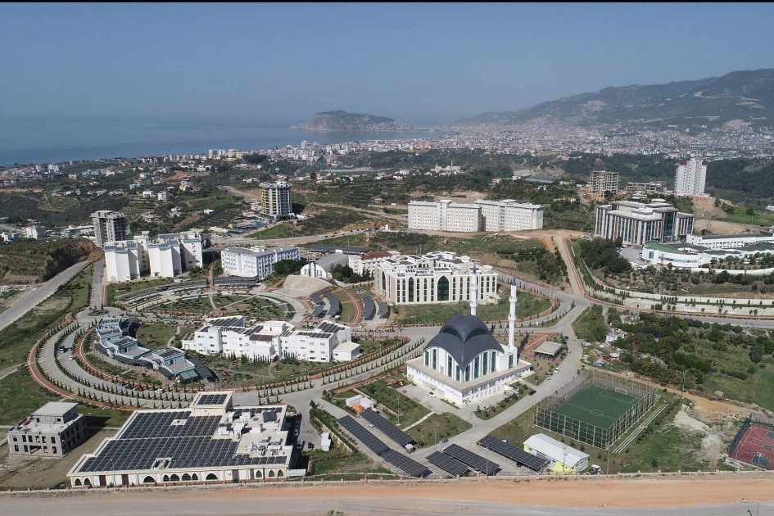

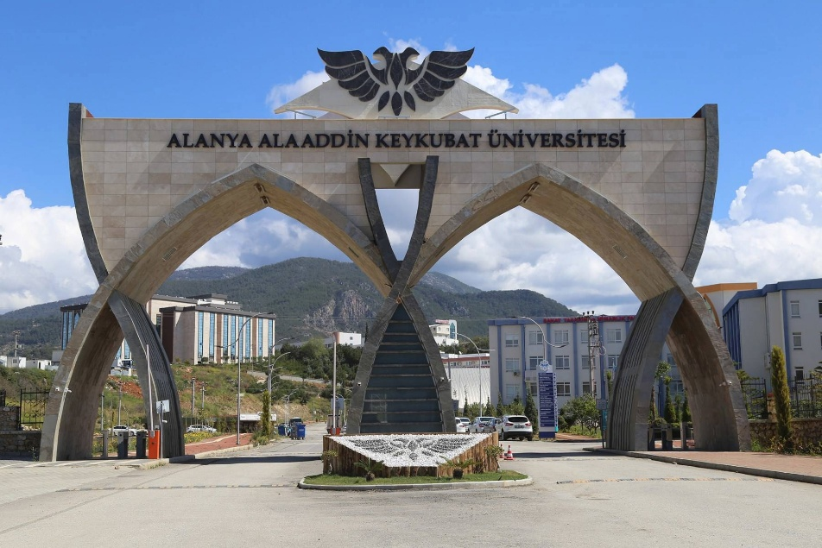

Turkish Lecturers:
Prof.Dr. Atılgan ATILGAN | Alanya Alaaddin Keykubat University, TÜRKİYE
Assoc. Prof. Dr. Ahmet COŞGUN | Akdeniz University, TÜRKİYE
Assoc.Prof.Dr. Meltem AKÇA | Alanya Alaaddin Keykubat University, TÜRKİYE
Asst.Prof.Dr. Gürkan ORTAMEVZI | Alanya Alaaddin Keykubat University, TÜRKİYE
Asst. Prof. Dr. Tuğçe ÇOPUR | Alanya Alaaddin Keykubat University, TÜRKİYE
Asst.Prof.Dr. Levent KAYA | Alanya Alaaddin Keykubat University, TÜRKİYE
Asst. Prof. Dr. Mustafa ALTINTAŞ | Alanya Alaaddin Keykubat University, TÜRKİYE
Lecturer Leyla AKBULUT | Alanya Alaaddin Keykubat University, TÜRKİYE

Foreigner Lecturers:
Prof. Dr. Roman ROLBIECKI | Bydgoszcz University of Science and Technology POLAND
Prof. Dr. Oleksandr ZBRUTSKYI | Igor Sikorsky Kyiv Polytechnic Institute, UKRAINE
Prof.Dr. Marcin NIEMIEC | University of Agriculture in Krakow – Kraków, POLAND
Assoc.Prof.Dr. Meltem Yavuz SERCEKMAN | Brunel Univesity of London, ENGLAND
Asst. Prof. Dr. Joanna KOCIĘCKA | Poznan University of Life Science, POLAND
Asst. Prof. Dr. Dmytro ZINCHENKO | Vilnius Gediminas Technical University, LITHVANIA
Contact person for any questions: Prof.Dr. Atilgan ATILGAN, Engineering Faculty, Department of Biosystem Engineering, email:atilgan.atilgan@alanya.edu.tr

